On following step of checkout, after selecting address and pressing continue:
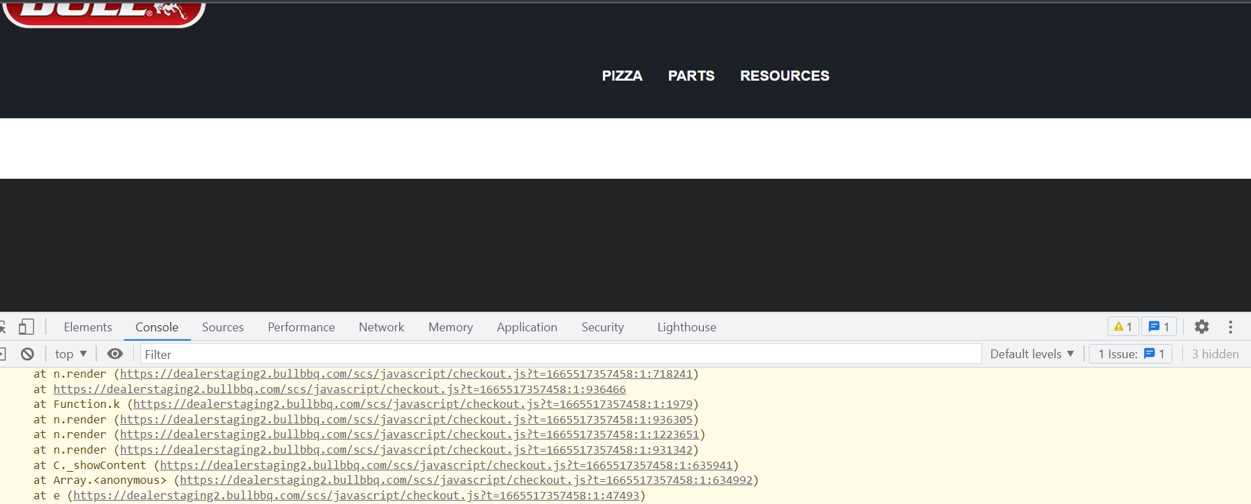
I turned off all the extensions:
- checkout
- columns
- core content
- custom fields
- featured category
- featured product

- horizon theme
- image text overlay
- infinite scroll
- inventory display
- item badges
- logo list

- order status

- photo gallery

- product page printer

- stock notifications
- suitecommerce cpq

Luego, desactivo todos los scripted records: Customization -> Scripting -> Scripted records: select sales order:
- user Event scripts: todos activos menos pacejet sales order integration
- client scripts: todos activos hasta AVA_transaction_Client incluido activo
- workflows: all released
Ultimo step a chequear:
En consola, presiono en la primer línea, y pongo un breakpoint:
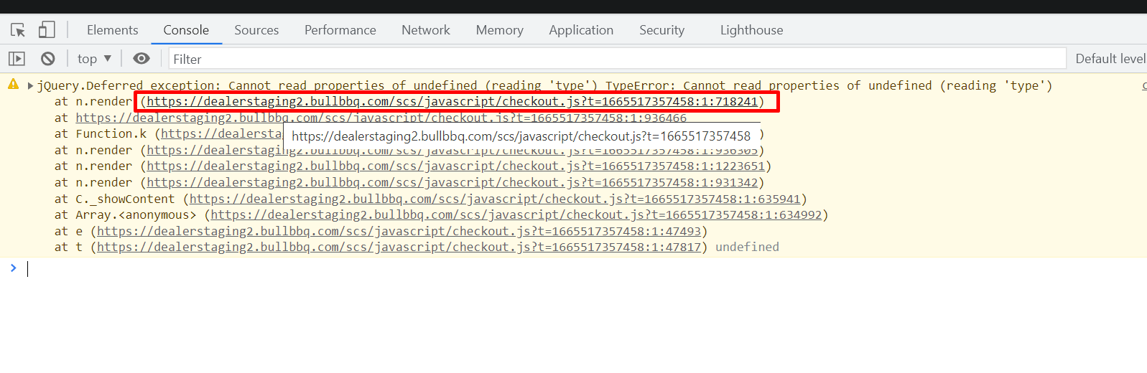
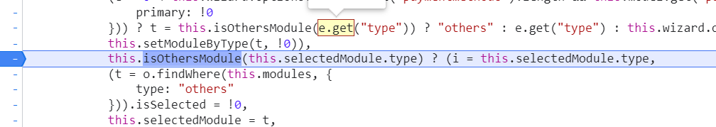
Podemos ver que este selectedModule viene undefined.
De ahí subimos un poco para ver a quien pertenece:
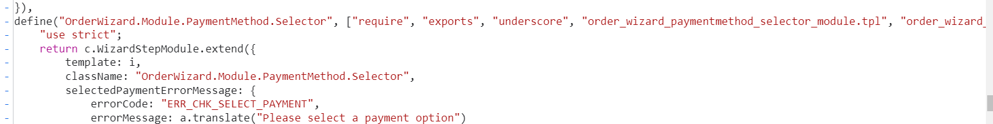
Veo que pertenece al order wizar module de payment method. Entonces, el error es de algo de ahí.

